The Magic Flute and Images of Jungian Psychology
Paper written for Pacifica Graduate Institute
Kayleen Asbo, Ph.D

Amongst the many symbols that emerge from the collective unconscious, there are seven which stand out as particularly important in the individuation process: the Shadow, Wise Old Man, the Child, the Primordial Mother, the Maiden, the Anima and the Animus. (Jacobi 114). All seven are present in particularly important ways in Mozart’s last opera, Die Zauberflote (The Magic Flute). Indeed, the entire opera can be read as an alchemical allegory of the soul and the journey towards individuation.
Mozart himself was the embodiment of the puer archetype, the image of the eternal Divine Child. Perhaps the most famous child prodigy ever known, he composed his first symphony at the age of eight, his first opera (a sanitized and heterosexualized variation of the mythological story of Apollo and Hyacinthus) at the age of twelve. By the time he was a teenager, he had mastered thirteen languages, and demonstrated that he could play both the organ and the violin without any previous instruction (Knepler 5). He was obsessed as a young child with mathematics and would cover walls, tables and floors with sums in chalk (Deutsch 452). He loved literature and wrote several comedies for theater (Knepler 8). His feats of memory were considered impossible; his improvisational ability godlike. As a teenager, he was acknowledged as the foremost pianist of his day, and his father also felt he possessed the potential to become the greatest violinist of his generation. So pure was his boy

Asbo 2
soprano voice that an Italian singing teacher attempted to persuade him to become a castrato – an act which would have enshrined his youth in the most literal (and painful) of ways.
Mozart was never able to extricate himself from the identification with the child archetype. In its bright aspect, it gave him (and his music) a sense of utter naturalness, an unstudied grace, a playful exuberance and a charming innocence. In its darker aspect, the Child showed his face in wayward petulance, impetuous spending sprees, public tantrums, shocking scatological humor and crudity, and an inability to manage his financial affairs- all things which repeatedly jeopardized Mozart’s career . The glory of Mozart’s early years as a “divine child” overshadowed his life. A pretty little boy, he was a short, funny looking and pockmarked man. When he turned his attention to writing music of a more complex and darker nature, audiences stayed away: the brooding masterpiece Don Giovanni (which ends with the protagonist being cast down into Hell) received a paltry nine performances in Vienna during Mozart’s entire lifetime. While fame and fortune were showered on him as a child, Mozart’s years as a mature, independent composer were a long and painful slide downwards from the pinnacle of success he had reached as a golden youth.
In his last years, The Magic Flute stands out as perhaps Mozart’s only unqualified commercial success. It was written in the final year of his life, amidst a sea of financial debt and growing health issues and yet, remarkably, it is the ultimate expression of child- like wonder. Commissioned not by a serious opera house but by a Singspiel company (the equivalent to a vaudeville troupe or off-off Broadway theater), the opera featured a production that was crafted to include rank amateur singers in a celebration of all that is whimsical, magical, and even downright silly at times: the truest expression of Mozart’s puer aesthetic. In this work that has been the delight of children for
Asbo 3
centuries, Mozart was able to create not only his most popular and enduring work, but one which touches the eternal themes of individuation and transcendence and becomes a mirror for the alchemical process.
At first glance, The Magic Flute has many of the elements of a typical fairy tale. As the curtain opens, we see Tamino, archetypal hero, brandishing a sword as he faces a giant serpent. He finds himself in the company of a comedic sidekick, a strange birdcatcher, Papageno, who boasts that he deserves the credit for Tamino’s escape. The three women, servants of a Queen, arrive to reveal this as a lie and punish the offender. They show Tamino a portrait of a princess, Pamina, who has been abducted by her enemy Sarastro, and implore him to rescue the Maiden. Tamino falls instantly in love with the image and agrees to go after her. He encounters the evil Monostatos (servant of Sarastro), rescues the princess and then undergoes a series of trials in order to prove himself worthy of inheriting both a bride and a kingship.
So far, this seems to follow the standard outline of many an opera: a noble prince rescues a maiden and faces a series of heroic tasks. However, things are not at all as they seem at first glance. The hero does not actually slay the dragon- in fact, he faints: it is three women, the servants of the Queen of the Night, who actually vanquish the demon. The Queen, who begets on our sympathy in Act I when we see her as Pamina’s grieving mother is revealed later to be bloodthirsty and full of vengeance, while her nemesis, Sarastro, who first seems the embodiment of an evil ruler demanding droigt de seigneur, is later revealed to be a priest of the Temple of Isis and Osiris- full of wisdom, beneficence and forgiveness. It can even be argued that the princess ultimately rescues the prince.
Asbo 4
The Magic Flute has bewildered musicologists, who have struggled to account for the plot turns, reversals and paradoxes in these important characters (Davenport, Deutsch, Knepler). In addition, The Magic Flute thwarts all operatic convention by having the climactic love duet occur not between the prince and princess, but between the heroine and the comedic sidekick. Together Pamina and Papageno sing in tender and rapturous melodies:
(Love’s) high purpose clearly proclaims:
there is nothing nobler than woman and man.
Man and woman, and woman and man,
reaching towards the Deity. (Act I, Scene 7)

None of this makes sense from a conventional musical or literary perspective. However, seen from a Jungian perspective, all of the oddities and peculiarities of this extraordinary work fit in beautifully with archetypal psychology and the development of the Self, with each major character in the opera representing an important aspect in the individuation process (see Table 1). I agree with Dorothy Koenigger, who claimed that “all the main characters of The Magic Flute are joint participants in one being, one psyche, or one soul” (Heartz 279) who ultimately are integrated and united.
For in Die Zauberflote, there is not one couple who ultimately ends up bethrothed; there are two, yielding four individuals who are in a quest for love and union, and “in psychological terms, we usually consider the number four to refer the four psychic functions of thinking, feeling, sensation and intuition (Edinger Ego 265).” Where Prince Tamino is handsome, stalwart, courageous and filled with honor, his alter ego Papageno (who appears immediately next) is ridiculous (attired in a bird costume), cowardly, foolish, boastful and deceptive. Tamino’s highest value is knowledge and wisdom (which show his esteem of and embodiment of the Thinking function): he seeks to be
Asbo 5
initiated into the temple of the enlightened. Papageno, however, is the compensatory figure for this heroic stance: he declares that he “wants not wisdom but only food, wine and a pretty woman” (Mozart 17 ), showing that he values the Sensation function. Pamina, young, virginal and innocent, embodies Feeling. She is the figure inclined most to love and compassion, but also the depths of despair, contemplating suicide when she feels her love is not returned. Pamina’s innocence is counterbalanced by Papagena, who first appears in disguise as a crone and who boldly manipulates and seduces Papageno.. She represents the function of Intuition. The Intuitive type, Jung wrote, is dependent on the world of the imagination where “ facts are only acknowledged only if they open up new possibilities for advancing beyond them and delivering the individual from their power ( Jung 222).” Hence, when Papagena is asked by Papageno at their first meeting what her boyfriend’s name is she cries out, “ His name is Papageno!”, only to immediately disappear. In every scene she is in, Papagena is oriented to imaginal possibilities rather than current realities. This is most vividly seen in her delightful final duet in which she envisions a flock of children with her future husband.
All four of these characters can be seen as aspects of the Self, with each couple providing the compensatory function for their mates’ dominant function: Tamino’s Thinking is balanced by Pamina’s Feeling; Papageno’s Sensation is balanced by Papagena’s Intuition. Together, this foursome creates the quaternity that Jung saw as the symbol of “structural wholeness, completion- something static and eternal” (Edinger Ego 188).
The study of alchemy occupied Jung for much of the later part of his life. Part of this process of alchemy involved a search for the missing “fourth”, the missing aspect of the psyche that would lead to the Transcendent Function. “Jung over and over again in his writings returns to the alchemical question: ‘Three are here but where is the fourth?’ ” (Edinger Ego 189).
Asbo 6
While the literal goal of the medieval alchemists was the quest to turn base metal into gold and find immortality through the discovery of the Philosopher’s Stone, at a symbolic level alchemy was the long process of refining the soul, and the “the Philosopher’s Stone a symbol for the Self” (Edinger Ego 261). The end goal was what Jung referred to as coniunctio, a marriage of the conflicts within. “The factors which come together in the coniunctio are conceived as opposites, either confronting one another in enmity or attracting one another in love. To begin with, they form a dualism”, writes Jung in the Mysterium Coniunctionis (quoted in Edinger Mystery 12) and it is indeed this play of opposites which forms the backbone of the Mozart’s drama at every level of the libretto. Not only are the two couples opposites from one another (with the nobility, elegance and virtue of Prince Tamino and Princess Tamina in delightful counterpoint with the silly, immature and spontaneous pleasure seeking of the two Bird Lovers), but other sets of characters achieve a symmetry through opposition as well. The three mature woman who appear as Sirens, attempting to lure the Hero away from his quest are contrasted with the three young innocent boys who float down from heaven in a balloon and console the Heroine, urging her onward. The Queen of the Night, whose symbol is the moon, is at odds with the priestly king Sarastro, whose symbol is the sun. Papagena, the last character of the quaternity to appear is herself a marriage of opposites and paradoxes. She appears first disguised as an old crone, but gives her age as “Eighteen years and two minutes old” (Mozart 78), recalling Edinger’s description that the Philosopher’s Stone is “identified as an aspect of the Self by the fact that it is paradoxically both young and old, i.e. transcends the category of time ( Edinger Ego 274)”.
The Great Work of alchemy proceeds in four major stages: Negredo (blackening), Albedo (whitening), Citrinitis (yellowing) and Rubedo (reddening) (Henderson and Sherwood 15). These stages and their
symbols are mirrored throughout the opera, where the original set and costume designs give explicit instructions to follow this sequence of colors. The Negredo stage is marked by separation and
Asbo 7
putrefication: its color is black. In the first act of the opera, Tamino enters a black stage and encounters a black serpent. He learns that Pamina has been separated from her mother, abducted by a Black Moor wearing black, which is analogous to a confrontation with the Shadow, the archetypal force that Jung saw as a pivotal challenge, “essential for any kind of self knowledge” (Jung 145).
The second stage, albedo, is ruled by the color white: its symbols are the moon and the feminine, and it is the stage in which the contrasexual soul images (anima and animus) are emphasized and purification of the soul occurs (Henderson and Sherwood 202). Pamina and Tamino do not actually meet face to face and fall in love with one another as embodied people until after each one is confronted with a negredo image- in the case of the hero, the snake, in the case of the princess, the would- be rapist Monostatos. In the midst of their trials of purification in Act II, the Queen of the Night enters wearing a white gown on a white crescent moon, surrounded by a shower of white stars (see illustrations below), concretely embodying the albedo stage of alchemy.
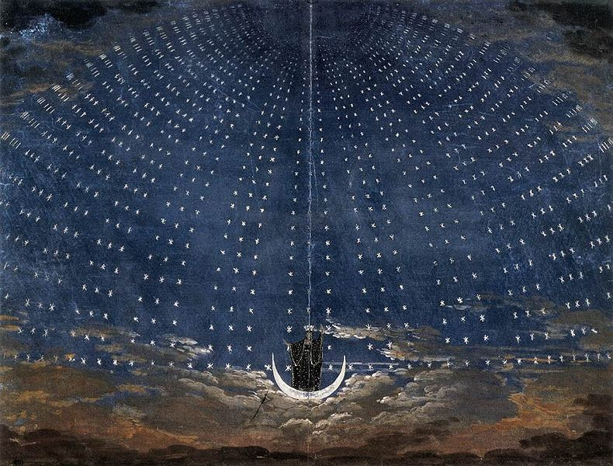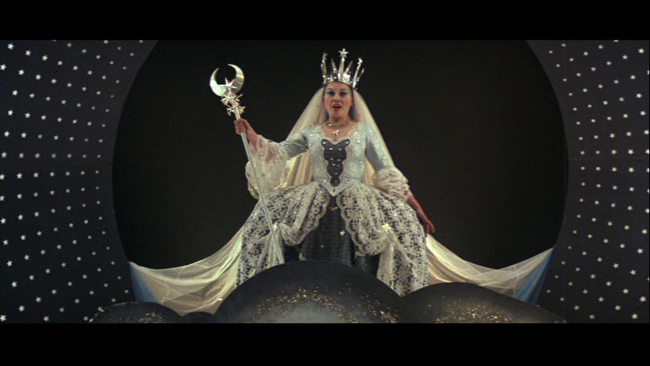 Original costume and set design for entrance of the Queen of the Night (left), recreated in the film Amadeus (right)
Asbo 8
The Queen of the Night is perhaps the most complex and fascinating character of the opera, showing the maternal (feminine)archetype in both its positive and its negative form. In her first, very sympathetic appearance, she seems as a variation of Demeter- a frightened and grieving mother desperate for the return of her beloved child. It is because of the intervention of the Queen’s three female servants that Tamino is able to escape from the dragon, and in this beneficent form, she gives him both the promise of love (her daughter Pamina) and the means of his salvation (the enchanted flute). When she returns upon a crescent moon in Act II, Scene II to meet Pamina, however, we have a very different side of the archetype: the all devouring mother. She demands that Pamina seek vengeance through murdering Sarastro in Der rolle Nicht, one of the most musically difficult arias in all of western musical literature to perform and one of the most bloodthirsty battle cries ever uttered:
Hell's vengeance boils in my heart;
Death and despair, blaze around me!
If Sarastro does not feel death pains because of you,
Then you will be my daughter nevermore.
Disowned be forever,
Forsaken be forever,
Shattered be forever
All the bonds of nature
If Sarastro is not bleached because of you!
Hear, gods of vengeance, hear the mother's oath! (Mozart 133)
In both her positive and negative aspects she is a vision of the “Chtonic Mother” which is the missing “fourth element” in the search for the transcendent in a woman (Jung 161).
Asbo 9
Meanwhile, Sarastro, initially presented as a figure of evil who kidnaps a young maiden (and, it is implied, intends to ravish her), is transformed in Act II. He becomes the “good” father, advocating both mercy and justice and hailed by a chorus of priests and initiates with the words:
It is he to whom we gladly submit!
In his wisdom may he always enjoy life
He is our idol, to whom all are devoted (Mozart 145)

Later, Sarastro is described as the possessor of “divine wisdom” (153). Sarastro dominates the second part of Act II, directing the young couple on a course towards enlightenment, and the stage directions specified that he is to be dressed in gold, with the symbol of the sun. This aligns with the third stage of alchemy, citrinitas (Henderson and Sherwood 145) in which the “yellowing” of solar consciousness is symbolized by the archetype of the Wise Old Man, the fourth element which completes the search for the Self in a man ( Jung 161).
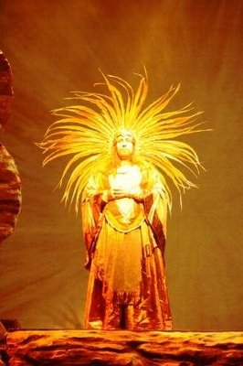
Original set design for The Temple of Initiation flanked by contemporary interpretations of Sarastro

Asbo 10
In this third stage, the couples pass through dangers and temptations as they seek initiation into an Enlightened state of being. Tamino and Pamina must endure trials by silence, by water and by fire before they pass through into the brotherhood of the blessed. Meanwhile, Papageno must confront his own sense of futility and personal failure that he has become a “fool, forgetful of magical things” (Mozart 197). It is music that saves them all. Music, that divine harmony which Tamino produces on the enchanted flute and Papageno on his celestial bells, is what sees their souls through danger and despair and becomes the Philosopher’s Stone, the vehicle for unification.
The final stage of alchemy is rubedo, or reddening. Its aim, after all the preceding trials of the psyche, is a total fusion of spirit and matter, an epiphany of wholeness. In the climactic scene of Die Zauberflote, both couples are united in the temple of Isis and Osiris. The directions indicate
that the stage should be “transformed into a sunburst” (Mozart 187); the priests who greets the couples are to wear red, and a red sky is to be dawning behind the pyramid in the distance as the Three Boys offer flowers while the chorus sings:
Hail to you on your consecration! You have penetrated the night!
Thanks be given to you, Osiris, thanks to you, Isis!
Strength has triumphed, rewarding
beauty and wisdom with an everlasting crown! (Mozart, 208)
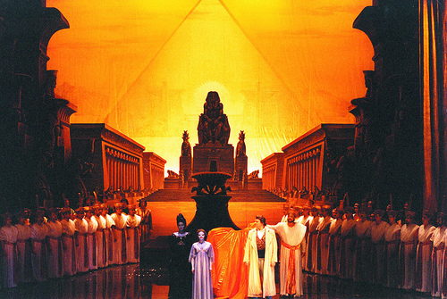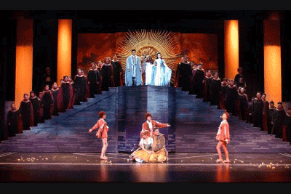
Asbo 11
Mozart’s decision to close the opera with a hymn dedicated to Isis and Osiris underscores the transformational journey of psychological wholeness, for this Ancient Egyptian myth of re-memberment and regeneration “points to psychic conception by a symbolic image rather than concrete reality” (Edinger Ego 274).
As an opera, The Magic Flute fails utterly to conform to 18th century plot traditions: the hero is cowardly and ultimately must be emboldened by the princess; the mother who at first grants a boon becomes the witch, the evil abductor becomes the sage. As a story of individuation, however, The Magic Flute is a fit companion and musical counterpart to Carl Jung’s own investigations and writings: a brilliant, luminous and beautiful illustration of the perennial themes of archetypes and the Great Work of alchemical transformation.

Table 1.
The primary characters, reflecting the Jungian archetypes, functions, and alchemical stages

Child(ren) Three youths who appear throughout, singing of hope
Tamino Prince, the Hero of the Quest Thinking
Pamina Princess, the Maiden in Distress Feeling
Papageno Birdcatcher- the Animus of Papagena (and perhaps Pamina) Sensation
Papagena Anima figure of Papageno Intuition
Monostatos The Moorish kidnapper, a collective Shadow figure Negredo
Queen of the Night Chtonic Mother, in both benevolent and malevolent guises Albedo
Sarastro The Wise Old Man Citrinitas
Temple of Isis/ Symbol of unification of Self Rubedo
Eye of Horus

Works Cited

Deutsch, Otto. Mozart: A Documentary Biography. Stanford: Stanford UP 1965.
Edinger, Edward. Ego and Archetype. Boston: Shambhala, 1972.
Edinger, Edward. Mystery of the Coniunctio. New York: Inner City, 1984.
Godwin, Jocelyn, “Layers of Meaning in the Magic Flute”. Musical Quarterly 65 (1979) 471-92.
Heartz, Daniel. Mozart’s Operas. Berkeley: University of California P 1990.
Henderson, Joseph L. and Dyane N. Sherwood. Transformation of the Psyche: The Symbolic Alchemy of the Splendor Solis. NY: Brunner-Routledge, 2003.
Jacobi, Jolande. Complex, Archetype, Symbol. Princeton, New Jersey:Princeton UP, 1959.
Jung, Carl. Ed. Joseph Campbell, transl. R.F.C. Hull. The Portable Jung. New York: Viking, 1971.
Knepler Georg, Wolfgang Amadee Mozart, Cambridge: Cambridge UP, 1994.
Mozart, Wolfgang Amadeus. Die Zauberflote. Budapest:Konemann Music, 1993.
Von Franz, Marie Louise.The Problem of the Puer Aeternus.Toronto: Inner City. 2000.

Interestingly, Jung identified “Don Juanism” as a notable characteristic of the puer aeternus (von Franz 7)
The Magic Flute is currently ranked number one as the most often produced opera in the United States. It is often used as an introduction to opera for children: several picture books of the story are in print and it has been the subjects of children’s films from the sublime (Ingmar Bergman) to the ridiculous (the Smurfs).
“At the beginning of his journey, Tamino simply projects his anima onto Pamina (in the opera, we may recall, he falls in love not with Pamina herself but with her portrait)”(Godwin 487)
As Jacobi notes, “ In the various mythologies snakes usually appear as companions or attributes of the great earth mothers. We encounter the serpent in connection with Hecate, the Greek moon goddess, and also with the goddess Demeter (149)”. It is also interesting to note that Papageno works catching birds for the Queen of the Night. As Edinger notes, birds are “spirit-potentials “which are “brought into reality by the lunar mode of being” (Edinger Ego 280).
Appropriate, given the history of the importance of music to alchemists, both in theory (echoing the ideas of Pythagoras and Plato) and in practice (Henderson and Sherwood 41).

