The Crone in the Corner: The Lasting Legacy of the Cumaean Sibyl
By Kayleen Asbo

One of the most memorable moments of my life as a musician was singing the magnificent Requiem of Mozart, that last and darkest work of the great master featured so pivotally in the climactic death bed scene of the Oscar winning film Amadeus. Who, having seen the film, can forget the poignant image of a frail and feverish Mozart dictating to the eager Salieri a soundscape of flames searing up through the bass and cello lines? As I stood on the stage surrounded by an orchestra on Good Friday five years ago singing this masterpiece, the chorus shouted with terrifying intensity the words of the second movement, the Dies Irae :
Dies iræ ! dies illa
Solvet sæclum in favilla:
Teste David cum Sibylla !
(The day of wrath, that day
Will dissolve the world in ashes
As foretold by David and the Sibyl!)
The lyrics I had been singing in Latin for months suddenly struck me with great shock: foretold by King David and who? What sibyl?
Lurking behind the creative fiction of the penultimate scene of Peter Schaffer’s Amadeus is another story, perhaps even more fascinating and worthy of enthronement by the producers in Hollywood: the true history of how the Sibyls, the female oracles of the Ancient World, defied the fate of so many of their divinatory kin. Unlike those thousands and thousands of wise women who ended up on the burning stakes with every trace of their life and work reduced to ashes, the Sibyls
endured in Western culture and they remain with us still, peeking out from the rafters of Michelangelo’s Sistine Chapel, tucked away into the folds of the most sacred musical liturgies of the Catholic church, referenced in sources as disparate as Virgil, St. Augustine and Van Eyck, and immortalized in Thomas of Celano’s 13th century poem that became the basis for Mozart’s fiery movement. As the crones in the corner of history, the Sibyls provide a fascinating and illuminating bridge between the Pagan and Christian worlds, pointing in the shadows to the important role that women once played in religion and prophecy.
The first mention of a Sibyl may occur in the writings of Heraclitis. In a fragment dated around the 5th century BCE, he observed, “The Sibyl, with frenzied mouth uttering things not to be laughed at, unadorned and unperfumed, yet reaches to a thousand years with her voice by aid of the god” (Takacs 61). During the time of Plato, there was thought to be only one Sybil; by the time of the Romans, ten were said to reside in temples and caves throughout the Ancient world, figuring prominently in both history and mythology. In the Medieval age, the number of Sibyls expanded to twelve in order to mirror the sacred number of disciples. Though legends ascribe mighty works and words to each, the “highest priestess and the highest authority in the known world” (Goodrich 44) was the Cumaean Sybil.
In the historical account of Varro (a summary of which survives in the works of both Lactantius and Origen), this woman arrived at the court of Tarquin to sell to the king a set of nine books of prophecy at an outrageous sum (Takacs 64). The king refused. She promptly burnt three of the books and offered the remaining six at the same exorbitant sum. He refused again, and she burned three more. Finally, court diviners convinced the king to purchase the remaining three books at the original asking price for nine. These prophecies became enshrined in Roman history as the Sibylline Books, oracular testimony believed to be so powerful that “they played a crucial role in the legitimization of religious innovation and the formation of Roman religion” (Takacs 66). Housed
first at the temple of the Capitoline Jupiter and later at the Palatine Apollo, colleges of priests were formed to consult the books during times of political and social crisis, and severe penalties (including drowning) were imposed on unauthorized access to the testaments ( Takacs 63). The Sibylline Books were pivotal in the process of Rome’s cultural assimilation: not only did they merge Etruscan, Trojan and Greek elements, but the texts themselves are credited with the introduction of the cults of Apollo, Ceres (Demeter) and, most especially, the Great Mother (Magna Mater) into Roman society (Takacs 65). During the Second Punic War, circa 200 BC, the oracular college determined that the books promised victory over Carthage if Cybele were brought to Rome (Durant 94). Ovid memorializes this occasion in the following way in Fasti:
When Rome was more than five centuries old,
And had lifted its head above the conquered world,
The priest consulted the fateful words of Euboean prophecy:
They say that what he found there was as follows:
‘The Mother’s absent: Roman, I command you: seek the Mother.
When she arrives, she must be received in chaste hands.’ (Book IV)

Amidst great ceremonial rites with incense, a procession carried the black stones associated with the Phrygian goddess to the Temple of Victory, which were looked after thenceforth by self castrated priests (Durant 95) , prayed to by Roman women, and washed by the Vestal Virgins every March 27 in a public celebration (Goodrich 364).
The Sibylline Books assumed a pivotal role in Roman political and religious life for at least 800 years; the Cumaean Sibyl’s own mythical life was supposed to have lasted even longer. In Book Fourteen of The Metamorphoses, Ovid tells the tragic story of her fate. Wooed by Phoebus Apollo, she was promised years as many as the grains of sand in her hand, but when she spurned the god’s sexual advances, he refused to grant her perpetual youth along with longevity. She was doomed to wither away over ten centuries, eventually becoming so tiny that she lived in a small jar (ampulla) writing her prophecies on oak leaves. Later legends say that finally only her voice remained; in the
epigraph to T. S. Eliot’s “The Wasteland” (taken from Gaius Patronicus’ Satyricon), when asked by children what she wants, her faint voice replies, “I want to die” ( Eliot 75).
It is this same legendary woman that Virgil places in a pivotal role in The Aeneid, as Aeneas’ guide to the underworld. It is she who lives in a cave at the mouth of Averno, and it is under her tutelage that Aeneas breaks the golden bough and then follows into underworld to see again the shades of his past and consult his Father, Anchises, before returning to the upper world to establish Rome.
Virgil again evokes the Cumaean Sibyl in his Fourth Ecologue, and it is her presence here in this particular poem that may have enabled Virgil’s own survival in Western culture long after the Sibylline Books and so many other pagan writings were destroyed , for the Fourth Eclogue was interpreted by early Church Fathers as a prophecy of Christ’s birth: the “final age” she foretells in the birth of a Virgin’s child was interpreted to be confirmation of Christian doctrine. In certainly one of the most ironic movements of history, it may have been Augustine of Hippo who ensured that the legends of the Sibyls would endure in the Christian world. In The City of God, he recounts the story of a famous ancient prophecy (whether by the Cumaean or the Erythraean Sibyl, he is not sure) “which had the initial letters of the lines so arranged that these words could be read in them: 'Ihsous Xristos Qeou uios spthr, which means, ‘Jesus Christ the Son of God, the Saviour’” (Book VIII Chapter 28). Augustine marveled at the numerical significance of the writing : 27 lines, one of the most potent numbers for those who look for meaning in such things, symbolizing “ with three to the power of three, an emblem of the Trinity” (Dronke 9). This prophecy so impressed Augustine that he allowed (perhaps grudgingly) that “ we might even think she ought to be reckoned among those who belong to the City of God” (Augustine 28).
Augustine and the Cumaean Sibyl are linked visually in the following Book of Hours dating from the 15th century (Figure 1) . Here the Sibyl’s words are used as proof of Augustine’s theological position (note that in her visual placement she is “backing him up”). What makes it particularly peculiar is that Augustine is condemning Porphyry (see City of God, Chapter 27) for his involvement in magic and divination -the very things that Sibyls were renowned for- a condemnation which paved the way for the horrific witchburnings of women in later centuries by professed Christians (Tobin).
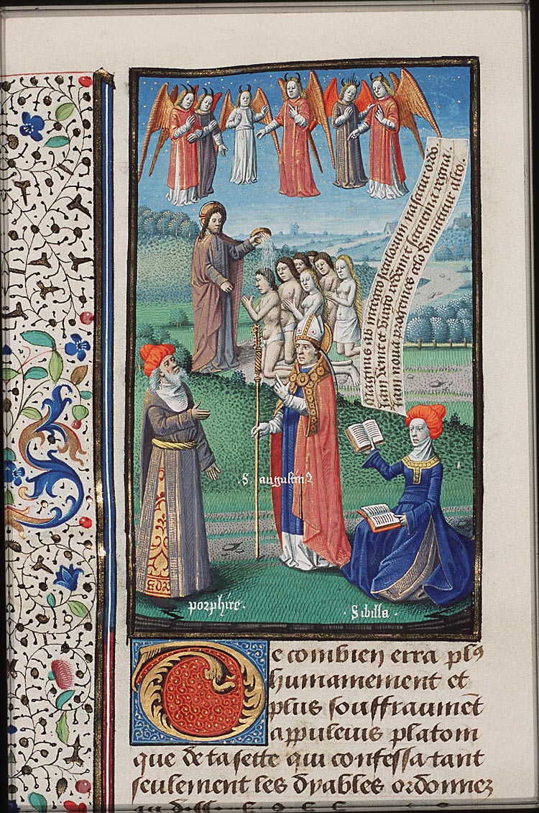
Figure 1: St. Augustine and the Cumaean Sibyl Refuting Porphyrus, French Master, 1475
By the Middle Ages, Augustine’s Latin translation of the Sibyl’s prophecy , known as “Judicii Signum”, found its way into the heart of the Catholic liturgy for Christmas. It was sung throughout the region of Aquitania (present day southern France) from the 9th century, reaching the zenith of its compositional sophistication in the Aquitanian monastery of St Martial near Limoges during the 12th century (Track 2) . The appended lyrics include the English translaton of 1610 by John Heally

The Sibyl’s prophecy had a central place in the liturgical dramas at cathedrals in Rouen, Munich and Rome; some of her lines also appear in the mystery plays which flourished in the quattrocentro in Italy and in the Nativity plays of England in the 13th through the 16th centuries (King). The “doomsday” motif of the Sibyl is also the root of Thomas Celano’s Dies Irae (Track 3), which centuries before Mozart set it to new music, was the canonical sequence hymn for all Requiem Masses (Henry 147) , and continues to be the opening hymn for Lauds and Vespers in the Liturgy of the Hours during Advent.
In Spain, another apocalyptic prophecy, the Song of the Sibyl , is still performed today in the Catalan language in a line of oral transmission almost unbroken from the 10th century . Declared a “Masterpiece of Oral Heritage” by the UNESCO foundation, it maintains a unique place at the beginning of the liturgy for Christmas Eve. Flanked by two torchbearer and dressed in a white cape and tunic, the singer processes to the altar of the church where he/she sings a solo of the chant like melody, all the while holding an enormous sword aloft. At the conclusion, the singer draws a cross in the air with the sword and is escorted away by the torchbearers as the service resumes. Like the Dies Irae, the words of this haunting music (Track 4) are hardly ones of comfort- rather, they are dark, foreboding and threatening.
Original Catalan | English Translation
Al jorn del judici parrà qui avrà fet servici. | The day of the judgement on those who don’t serve
Jesucrist, Rei universal, home i ver Déu eternal, del cel vindrà per a jutjar i a cada u lo just darà. | Jesus Christ, King of the Universe, man and true eternal God, from Heaven will come to judge and to give everyone what is fair.
Gran foc del cel davallarà; mars, fonts i rius, tot cremarà. Daran los peixos horribles crits perdent los seus naturals delits. | Great fire from the heaven will come down; seas, fountains and rivers, all will burn. Fish will scream loudly in horror as they lose their natural delights.
Ans del Judici l'Anticrist vindrà i a tot lo món turment darà, i se farà com Déu servir,  i qui no el crega farà morir. | Before the Judgment the Antichrist will come and will give suffering to everyone,  and will make himself be served like God, those who do not obey him he will kill
Lo seu regnat serà molt breu; en aquell temps sots poder seu moriran màrtirs tots a un lloc  aquells dos sants, Elies i Enoc. | His reign will be very short; in these times under his power will die martyrs, all at once  As those two saints, Elijah and Enoch, foretold
Lo sol perdrà sa claredat mostrant-se fosc i entelat, la lluna no darà claror i tot lo món serà tristor. | The sun will lose its light, becoming dark and veiled, the moon will give no light and the whole world will be cast over with sorrow.
Als mals dirà molt agrament: —Anau, maleits, en el turment! anau-vos-ne en el foc etern amb vòstron príncep de l'infern! | To the evil ones he will say with bitterness: -Go, damned, into the torment! Go inside the eternal fire with your Prince of Hell!
Als bons dirà: —Fills meus, veniu! benaventurats posseïu el regne que us he aparellat des que lo món va esser creat! | To the good, he will say: -My children, come! Lucky ones, you possess the kingdom I have intended for you since the world was created!
Oh humil Verge! Vós qui heu parit Jesús Infant aquesta nit, a vòstron Fill vullau pregar que de l'infern vulla'ns lliurar! | Oh humble Virgin! May you who have given birth to Infant Jesus in this night, to your son pray for us so that he will deign to keep us from Hell!
In the thirteenth century Passion of Revello, a copy of which survives in a manuscript dated 1490, the prologue contains directions for a procession of twelve Old Testament prophets and twelve Sibyls, with elaborate costume details and speeches for each one. This expansion to twelve took its most daring musical form in the Prophetiae Sibyllarum, a collection of extraordinary pieces written by Orlando Lassus (also known as di Lasso) in the 16th century. Following a Prologue as highly chromatic as any 20th century work, each of the now twelve Sibyls is given a Madrigal showcasing
one of her reputed prophecies (Track 5 is the Cumaean Sibyl’s Madrigal). Though unpublished during his lifetime, the work brought a great deal of notoriety to Lassus; the work was said to have shocked and “amazed” listeners (Haar 159).
The place of the Sibyls in the visual canon of is no less startling and noteworthy. In Van Eyck’s extraordinary Ghent Altarpiece (1432), the Cumaean Sibyl hovers over the scene of the Annunciation (Figure 2)
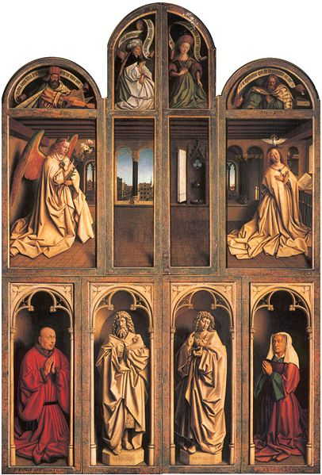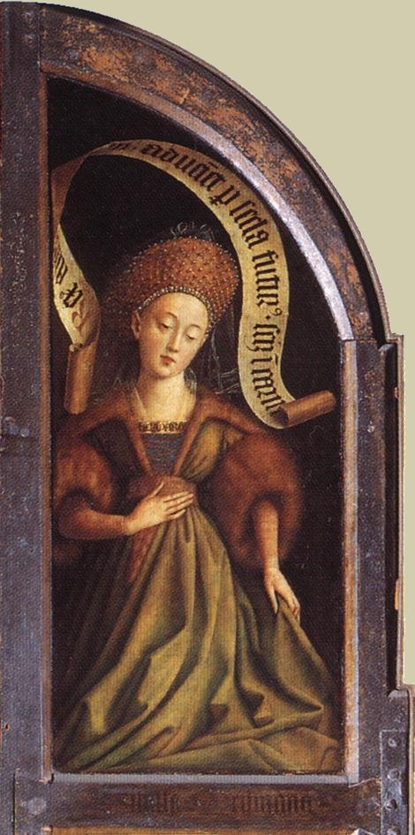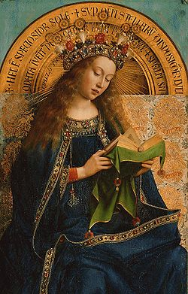
Fig. 2:Van Eyck, Closed view of Ghent Altarpiece Fig.3:Detail of Cumaean Sibyl Fig. 4: Interior Mary

Perhaps one of the most interesting aspects of her portrayal here is the opulence of her attire, all velvet and fur, with a headdress sewn with pearls (Figure 3). The other figure so lushly bedecked is Mary who sits at Christ’s right hand when the altar is opened (Figure 4). Their facial expressions are quite alike, as are their postures, features and the uniting symbol of the word (scroll/book). As portrayed here, the Cumaean Sibyl is clearly a figure of nobility, prominence and loveliness. Images. of the Cumaean Sibyl also proliferated in the “Jesse Tree”, stained glass windows placed in churches during the 12th through 15th centuries. Others were carved into the doorways and choir stalls of cathedrals at Rouen, Amiens, Laon, Toulouse, Auxerre, Orvieto and Strasburg (King).
Filippo Lippi, Domenico Ghirlandaio and Ludger tom Ring the Elder each painted important images of the Cumaean Sibyl. On the ceiling of Santa Maria Sopra Minerva in Rome, Lippi’s prophetess (Figure 5 ) gazes down from the ceiling with scroll in hand and a sheer gown falling suggestively from her shoulders. Her look, too, is suggestive, almost Aphrodite-like. Ghirlandaio’s version (Figure 6), in contrast, is all regal Roman respectability, while Ludger torn Ring the Elder’s image is both demure and winsome, despite her voluminous garb, as exotic as a Northern Protestant could imagine (Figure 7). 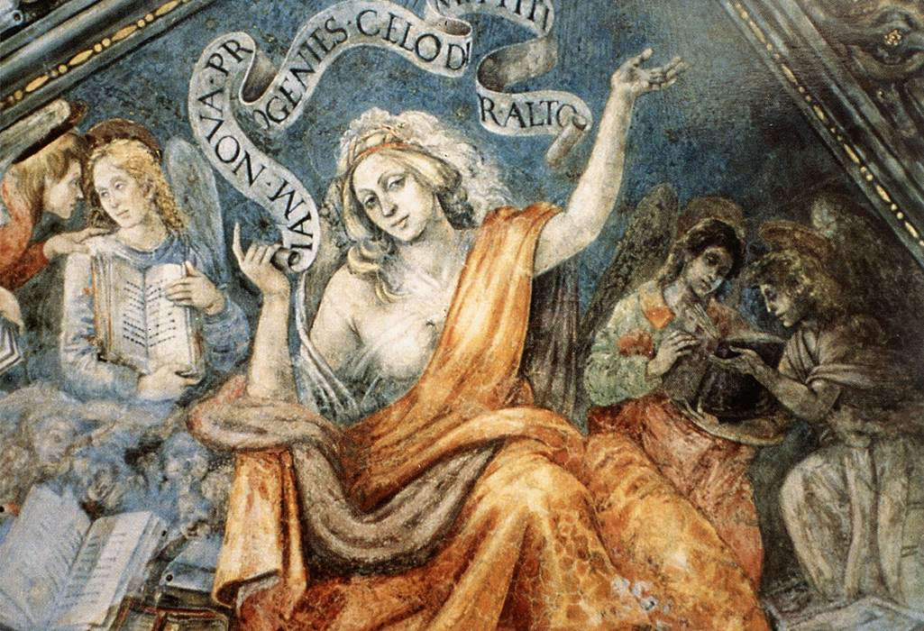
Figure 5: Cumaean Sibyl (Santa Maria Sopra Minerva), Filippo Lippi (1491)

By the time of the Italian Renaissance, the visual pairing of Sibyls with Jews was well established- the image below by Perugino is surely one of the most beautiful, with six male prophets of the Old Testament in harmony with six pagan prophetesses each wrapped in their predictions and clearly identified by their names inscribed at their feet (Figure 8) . Perugino celebrated the delicate grace and charming femininity of his Sibyls. Nothing could be further from this vision than Michelangelo’s massive and muscular figures that loom in the corner of the Sistine Chapel (Figure 9) . His Cumaean Sibyl is rough and mighty. Though her head is already shrinking like a walnut (a clever way to evoke her fate), she is a mighty force, utterly believable as a woman so powerful as to rebuff Apollo’s advances and chart the course of religion and politics in Rome for 800 years. Hers is the face of age undisguised, of power unharnessed, of wisdom sharp and bold and unafraid. Though her hair is bound, it is easy to imagine that this is the very woman who walked through the Underworld with Aeneas, the woman of whom Virgil wrote “Her breast heaves, and her wild/heart swells with frenzy; she is taller now/ Her voice is more than human, for the power /of the god is closing in, he breathes upon on her” ( Virgil Aeneid 6: 69-73). It is easy to see this as the one who “rages, savage, in her cavern, tries/to drive the great god from her breast. So much/the more, he tires out her wild heart, shapes by crushing force” (Virgil Aeneid 6 : 111-113).
Throughout much of my life, I have felt bereft of the images of powerful women like these: images of women writing and leading and speaking their minds and challenging political powers and holding religious leadership. While the face of the Virgin meek and mild is ubiquitous in European art, I had thought that all images of old and powerful women had been destroyed with the advent of Christianity. To find Her- the Crone- peering from the corners of the cathedrals, tucked away in the chants and preserved in the writings of the very church I had thought had destroyed Her is, for me, a discovery of indescribable delight and healing. In the Cumaean Sibyl is an image of wholeness: beautiful maiden, mature woman of spiritual force, wise elder, whispering ancient voice - all in one. In Her is a woman who reconciles and holds both the pagan and Christian worlds. As a figure who

embodies the tension of the opposites, she was the inspiration for some of the most extraordinary art and music ever created; she has much to whisper to us still about the shadows of the past.

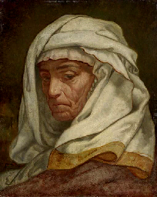
Cumaean Sibyl, Elihu Vedder (19th century)

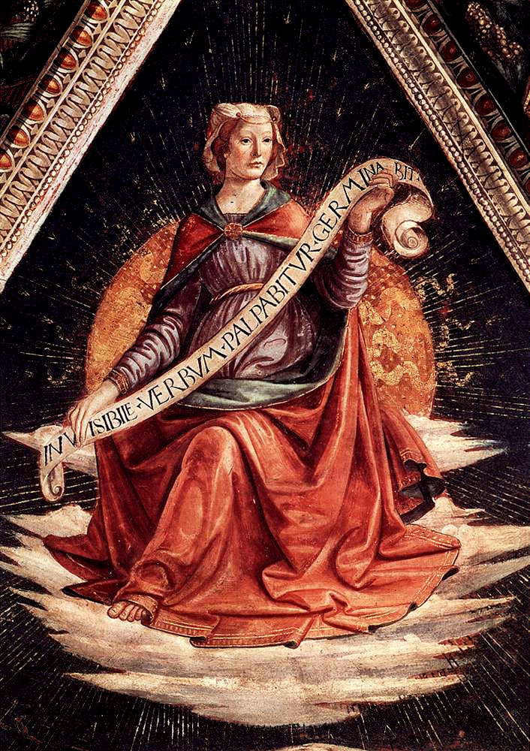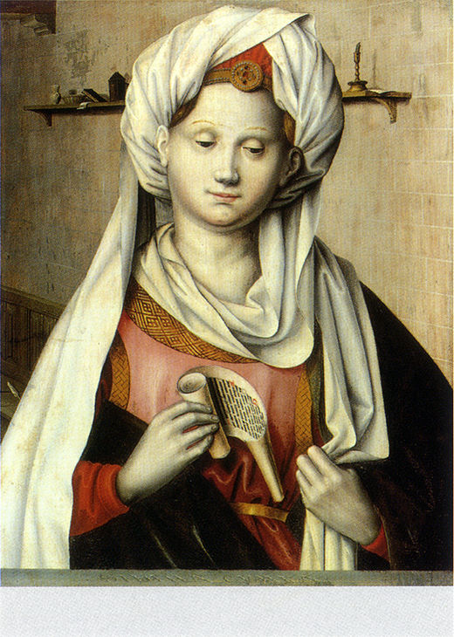
Fig. 6: Domenico Ghirlandaio, Sibyl (1483) Fig 7: Cumaean Sibyl (16th century) Ludger tom Ring
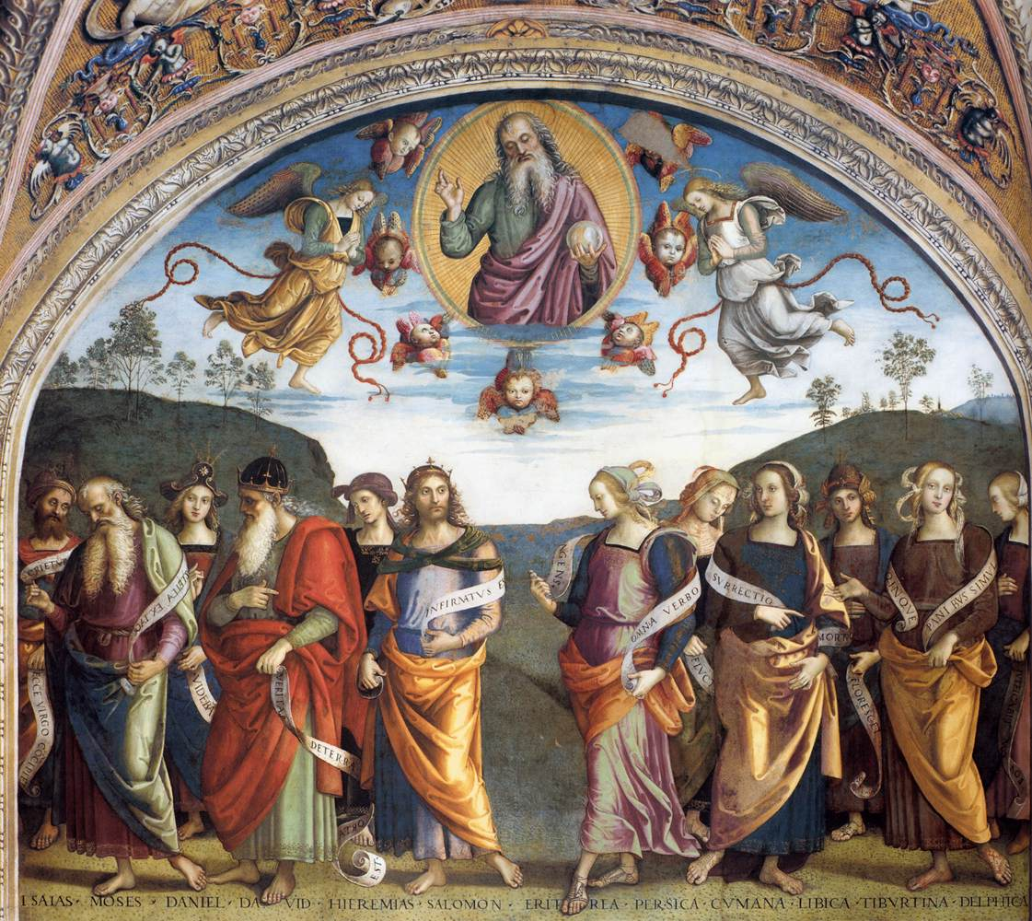
Figure 8: Perugino, TheProphets and Sibyls

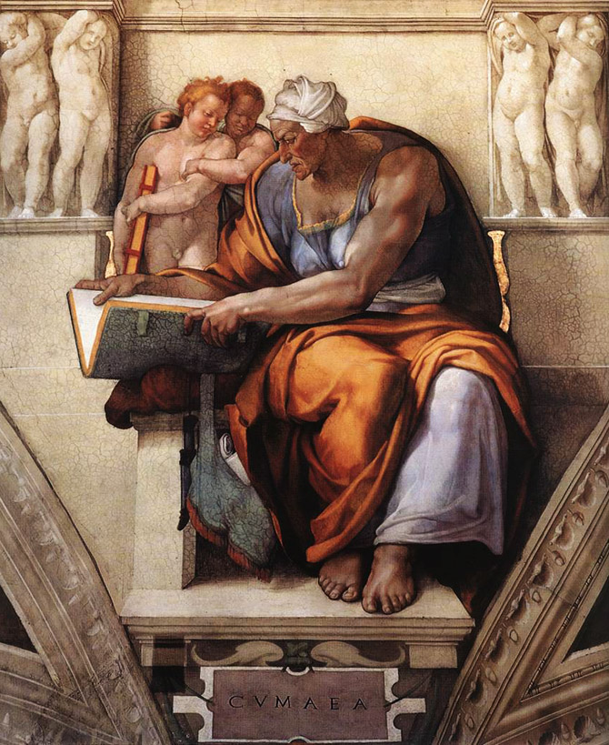
Figure9: Michelangelo Buonarotti, The Cumaean Sibyl, The Sistine Chapel (1510)

.

For example, the Persian Sibyl is crediting with foretelling the triumphs of Alexander the Great, who also consulted the Libyan Sibyl after his triumphant battle in Egypt .
There is a curious , provocative similarity between the words “Sibyl” and “Cybele”, though I have found no commentary that connects the two.
Euboan is another word for Cumaean.
In 405 CE by General Flavius Stilcho as he zealously pursued the eradication of paganism
? Ironic because of all early Christian writers, the author of the doctrine of Original Sin was perhaps the most vehemently misogynistic, going so far as to ask , “ Why was woman created at all?" and “Do women have souls?” ( Tobin) That Augustine may have been foundational in perpetuating the legends of the Sibyls and inspiring their depiction as prophets on par with the Old Testament patriarchs is rich irony indeed.
Persisting until 1962 when it was abolished by the second Vatican Council.
Almost unbroken, because its performance was banned by the Council of Trent in 1563, an edict which only held until 1575, when the ban on this piece was reversed.
Originally a female singer playing the part of the Sibyl, the role was taken over by a male youth once women were forbidden to perform in churches. Current practice favors performance by a woman once again.
Whether this woman is the Virgin Mary or Mary Magdalene is a subject of debate.

