Pythagoras: Father of Harmony
Kayleen Asbo, Ph.D

Most people know the sage Pythagoras only by the theorem that bears his name and yearly strikes fear into students of mathematics. As a young pianist and composer interested in art , philosophy and religion, I fought and rebelled against learning ancient geometric formulas I thought I would never use. My hapless teacher regrettably responded that, indeed, I probably would not ever need them-- especially since I was female.

How ironic it is then that the man who stands behind the formula of A2 + B2=C2 was not just a seminal figure in the history of numbers, but also the father of musical theory, the founder of Western philosophy, the hidden root of Western monasticism and an ardent proponent of gender equality. It is Pythagoras who lies beneath the surface of the understanding of proportion in Renaissance art and whose ideas of the music of the spheres rippled forth to influence Hildegard of Bingen, Johannes Kepler and Dante. It is upon Pythagoras’s giant shoulders that Plato and Aristotle stand, and it is his likeness that is inscribed in stone above the scholar’s doorway of Chartres, the most glorious Gothic Cathedral in the world that is a dazzling testament to the power of the ideas that were promulgated in his name.

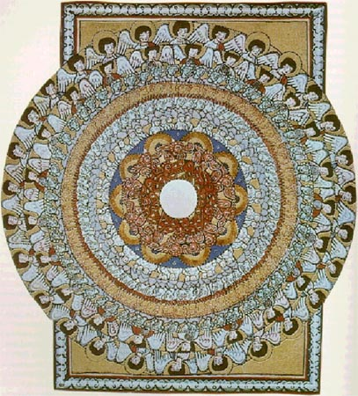
Hildegard von Bingen’s Vision of the Music of the Spheres

Pythagoras and the Pythagoreans offer us a worldview that does not divide life into art /math or religion/science. Instead, the Pythagorean perspective holds that there is a divine pattern that permeates every dimension of our universe. Harmony is the result of a dynamic, ever fluid weaving of the seeming opposites. If we search, we can find expressions of this pattern, this logos, in every facet of the world around us. We can discover it in the unfolding of the smallest chambered nautilus as well as in majesty of the spiral galaxy above us. If we have the eyes to see and ears to hear, we will find manifestations of the divine pattern in sound, number, form, and astronomy.

Pythagoras and the Pythagoreans

The actual facts of Pythagoras’ life are obscure. While a statue of him stood in the Roman forum for centuries to commemorate the “wisest of all Greeks” (Kahn, 86) , the reader seeking to find objective and verifiable accounts will be thwarted at every turn by a lack of contemporary historical evidence. Rather, we encounter (as we do in the stories of Jesus and Buddha) the outlines of a charismatic religious figure who left no written records himself but had a profound and lasting effect upon generations of those who followed his oral teachings. Those searching to find the “real Pythagoras” are further frustrated by a dearth of any biographical information penned within 150 years of his death. As written records did develop, they tended to become more and more grandiose. By the third century, anything of intellectual and philosophical merit was believed to have originated from “that man”: Pythagoras’s reputation was so great that followers were unwilling even to utter his name as a mark of almost divine respect, held as one of the seven greatest sages who had walked the earth. The question of where tradition becomes fantasy is more vivid and less resolvable in the life of Pythagoras than perhaps in any other historical figure. Pythagoras in our modern minds is associated with math, a subject filled with irrefutable, logical and austere proof. And yet Pythagoras the man is the slipperiest of personages, cloaked in mystery, shrouded in myth, and embellished with hyperbole. There is a certain poetic elegance to this conundrum, as a central tenet of Pythagorean philosophy was to honor both the rational and the irrational impulses of humanity.

From what we can reliably and consistently piece together, Pythagoras was born circa 570 BCE in Samos, off the coast of Turkey. His passionate search for knowledge led him to travel to all the cities of high learning in the ancient world. It is said that he imbibed the teachings of the Persian Magi, mastered the interpretation of dreams with the Hebrews, immersed himself into the hieroglyphic symbolism of the priests of Egypt and the absorbed the sagacity of the Chaldeans. When called the most perceptive of all persons, he demurred, modestly calling himself only “a lover of wisdom”. In so doing, he gave us the Greek word “philosopher”.

At the end of all his far-flung travels, Pythagoras returned to the Mediterranean lands of his birth where he established a school in Southern Italy that was devoted to both scientific and ethical study: both aspects were thought to be necessary in the pursuit of wisdom. For the first few centuries after his death, Pythagoras’s greatest fame actually rested not upon his mathematical formulas but as the founder of an ascetic way of life that emphasized dietary restrictions, religious ritual and rigorous self discipline. He revered the principle of unity in all things and taught that the soul was eternal. The telos, or object, of life was to purify oneself to become like god: to become a source of harmony in service of the cosmic order. This would be done in a succession of lifetimes. Through spiritual practice and study, Pythagoreans believed that one could both purify oneself and also come to remember previous incarnations. Pythagoras believed that we were intimately connected with one another in a matrix of creation. Nothing stood outside of this, and so all aspects of the earth should be treated with reverence. Animals deserved empathy; plants were to be seen as having their own form of intelligence. Conversation with and reverence of all creation, rather than subjugation and dominion, was the guiding principle. A life of wisdom could not dismember the pursuit of the mind from the care of the body or the cultivation of the spiritual senses. In order for wisdom to flourish in the individual, all aspects must be nourished and integrated in concert with one another and within the bonds of friendship. In order for wisdom to flower in community, the ethical, intellectual, political and spiritual must be all aligned and connected.

The Pythagoreans saw the human being as akin to a musical instrument. Like a great violin in an orchestra, we can become discordant by being out of sync with the vibrations around us. What the Pythagorean community sought was a way of life that would allow them to come into tune with the harmony of all creation.
Remarkable for its egalitarian spirit, members would enter and donate all their possessions to be held in common. Both men and women were free to join and to leave—and if they did depart, they would be given double what they had contributed to the community. A rigorous course of life was prescribed, built on a foundation of intellectual inquiry, music, physical exercise and above all, silence. In the mornings, the community would gather outside in silence to sing hymns to Apollo as the sun rose. After a day’s labor of individual work punctuated by walks in nature, they would gather together again in the evening to listen to the lectures of the master before dancing and singing hymns once more, ending in silence. Before drifting off to sleep at night, each member would conduct a moral inventory of three questions: “Where did I go wrong today? What did I accomplish? What obligation did I not perform?”.

Students in the first stages of instruction were known as auditores, or listeners, who were not allowed to ask questions but were to hear and memorize certain sayings, many which have the nature of zen koans. After successful completion of five years of silent study and initiation, they became esoterics, initiates into the inner circle of adepts. Aristotle reports that there were two rival schools of Pythagoreans: the akousmatikoi focused on ritual life, while the mathematekoi concentrated on the study of mathematics. Both circles pursued a lifestyle of simplicity where vegetarian diet, philosophical study and the disciplining of the passions were essential in the pursuit of an ethical life. The community flourished in Italy, where twelve hundred years later Benedictine monasticism took root. The parallels between the two lifestyles are striking, with their twin ascetic paths of study, silence and song. Both were in essence monotheists, though the Pythagoreans called God by the name of Apollo.

The Pythagorean curriculum comprised what later came to be known as the Quadrivium: arithmetic, geometry, music and astronomy. In this fourfold path, what was sought was the underlying principle of harmony that governed the cosmos. In each subject, the Pythagoreans sought to find the Divine Pattern. How was the sacred expressed in number? In geometric form? In sound? In astronomy? The Pythagoreans were searching for nothing less than God’s DNA—a sacred fingerprint that left its mark in all creation. A code of secrecy governed the Pythagorean teachings, which were delivered orally in order to be certain that the student was prepared to receive them. Attributed to Pythagoras and his community were the discovery of the five Platonic solids, the spherical nature of the earth , the full understanding of lunar and solar eclipses, the division of the Earth into five climactic zones and the discovery that “day” and “night” were the result of the Earth’s rotation. In his work On Heaven, Aristotle claimed that Pythagoreans held the view that the earth revolved around an orb of fire at the center of the cosmos. If this is correct, their studies brought them to heliotropic insights not commonly recognized until after the Copernican revolution two thousand years later.

A central tenet of Pythagorean life was the importance of balancing the opposites and the avoidance of excess. Vitality, beauty and well-being were to be discovered by harmonizing the following opposites:

Pythagorean Opposites
finite, infinite
odd, even
one, many
right, left
rest, motion
straight, crooked
light, darkness
good, evil
square, oblong
male, female

The Pythagorean rhythm of life seemed to also balance the multi-faceted needs of the human being. The community was composed of intellectuals who set aside time for exercise and dancing and abstract mathematicians for whom music and walks in nature were central spiritual practices. It was a life of shared community in which silence was an integral part. All of these point to a delicate and conscious balancing of seeming opposites.

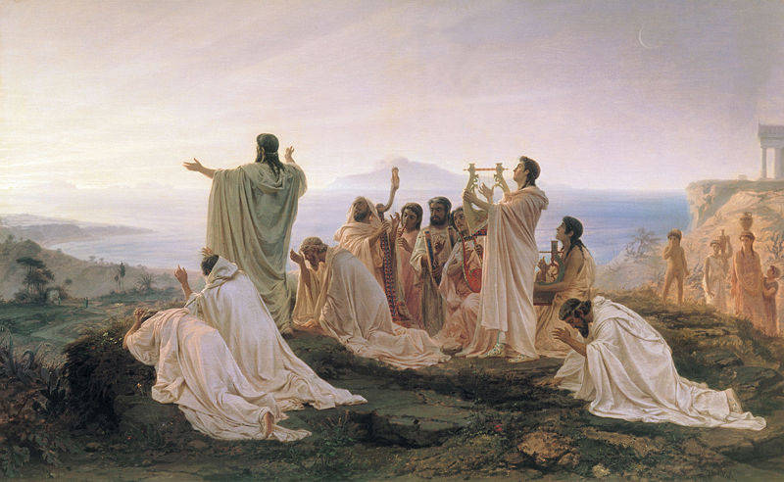

Pythagoreans, Fyodor Bronnikov (1869)

The Mythic Pythagoras: Shaman and Demi-God

Over time, as the Roman Empire increasingly embraced astrology and divination, Pythagoras’s legendary prowess in these realms grew, with magic replacing math as the focus of his legacy. Pythagoras’s relics and home became objects of veneration and pilgrimage by the first century CE. The writer Cicero described Pythagoras into a sorcerer who practiced divination and augury. Celsus portrayed him as a physician whose knowledge of plants and medicine was near-miraculous. Pliny the Elder viewed him as a genius who combined herbalism and magic.

In the five hundred years following his death, oral teachings mixed with fantastical legends that cloaked Pythagoras in mysticism and raised him to the status of a Demi-God. Pythagoras was said to have had a golden thigh; he was said to be able to recall his previous lifetimes in detail. There were several reports that Pythagoras had been able to bilocate. To explain his astonishing array of knowledge, people declared Pythagoras was the son of a god or of some race that was half human, half divine. In some versions of his later legends, his mother was said to be the Pythia, an oracle of the ancient world who was impregnated by Apollo. In a tale told by Peter Kingsley, Pythagoras was actually an incarnation of Apollo himself. During the 3rd- 4th centuries, Pythagoras seems to have emerged as a rival for the growing cult of Jesus. Like Christ, he was said to have raised the dead and to command nature, stilling the winds with the power of his incantations. New details about his appearance ( “majestic”, “tall” and “handsome”), garb (“always dressed in white”) and habits (a diet of honey and daffodil petals) also began to proliferate almost one thousand years after his death, adding color to his character.

It is during the first centuries of the common era that written Pythagorean texts with numbers began to proliferate, disseminated widely in the world. Whether this is because the oral traditions were simply being written down for the first time or whether they were deliberately forged under the great man’s name in order to be more readily embraced by the public is a subject of perpetual scholarly debate. The community Pythagoras had founded held all things in common: this included ideas as well as material property. The tendency of Pythagoreans and Neo-Pythagoreans over the centuries to ascribe all of their discoveries to their founder has complicated the search for historical facts. Modern writers describe even the Druids and Essenes as carrying forth the Pythagorean legacy of spiritual teachings and practice. This is challenging to prove. What is clear, however, is that much, if not most, of Platonic and Neo-Platonic philosophy is saturated with a Pythagorean influence. Works like the Timaeus , Phaedo, Meno and even The Republic rest upon the philosophical teachings of the Pythagoreans, particularly in the relationship between music, mathematics and the soul.

Pythagoras and Music Theory

While we search early texts in vain for the actual theorem that bears his name, what is consistent across the centuries about Pythagoras is his connection with music. Like Orpheus, Pythagoras was identified with the lyre and with his capacity to use melody as a vehicle for transformation and healing.

The Ancient Greek world did not see music as mere entertainment. Rather, it was a force that shaped the world and crafted character. It was a moral energy that bound together society. The correct application of music could heal- or harm. Most of Western music, whether classical or popular, confines itself to one of two modalities: either a major or a minor key. Most pieces that are meant to express happiness, contentment or joy are written in a major key; those that express anger, melancholy or despair are in a minor key. The Ancient Greeks were far more flexible and nuanced. There were seven modes, each the province of a different god, each associated with a different psychological state. Both Aristotle and Plato agreed that the modes of music used in educating the young should be carefully chosen. The application of the wrong mode could deform the character of an individual and even jeopardize the state.

Live music was not only essential in daily life, where it was to be found at the gymnasium as athletes practiced and competed. It was integral to well being. In the ancient Asclepeion, the centers of healing scattered around the ancient world, music played a foundational part of any cure. A patient who was suffering in mind, body or spirit arriving would undergo ritual purification. They would participate in the catharsis of a dramatic production and then incubate a dream in the temple. The following day, the physician would attend them. Part of the prescribed cure would be medicine--herbs and tinctures. But an equally important part of it would be the application of music therapy: a homeopathic immersion into the mode that would draw out the ailment. For mania, immersion into one mode would be called for; for depression and listlessness, a sound bath in another would be in order.

Greek Modes Effect and Use_________________________________

Dorian (d based) Music to awaken by
Develop clarity and awareness
Cultivation of moral virtue
Calm, well -being

Phrygian (e based) Fire, passion, boldness, courage but must be used carefully as could lead to rashness, anger

Lydian (f based) Good cheer, Laughter and love

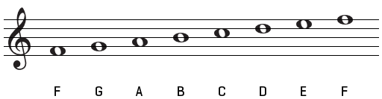

Aeolian/hypodorian (a) Thought to promote sleep and clarity of dreams

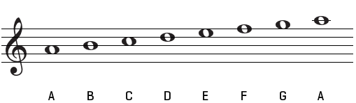

Hypophrygian (Locrian) (b) Pride, irritability, violence

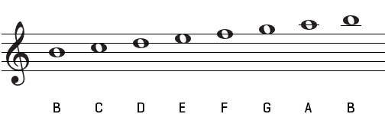

Ionian (c based) Sloth, drunkenness, moral depravity, indolence

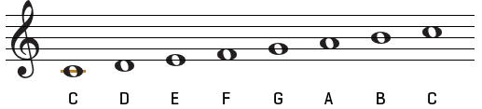

It is interesting to note that the modes Plato most associated with virtue (Dorian and Phrygian) have fallen almost entirely out of use in the West since the Middle Ages, while the mode he associated with moral depravity and sloth(Ionian) has increasingly dominated our world in the guise of C major!

The legends of Pythagoras illustrate his capacity as a sound healer. Through his lyre, he was able to create radical psychological shifts. In one famous story, he encountered a young man enraged and intent on murdering his unfaithful lover. Pythagoras, it is said, began to play in a mode that matched the cuckold’s rage, but modulated to a more serene and accepting tune. Having received this infusion of musical homeopathy, the would- be assailant put down his tools of destruction and placidly left the scene.

According to another folk tale, Pythagoras was walking past a blacksmith’s shop when he heard a ringing of beautiful sound. Perpetually tuned to finding the Divine Pattern in the cosmos, he investigated whereupon he discovered that the smith’s hammers were precisely constructed in perfect mathematical proportions of 2:1. Pythagoras replicated this ratio with bells, flutes filled water glasses and on a monochord’s strings and discovered that when mathematically pure ratios were present, the sound was harmonious indeed (see image).

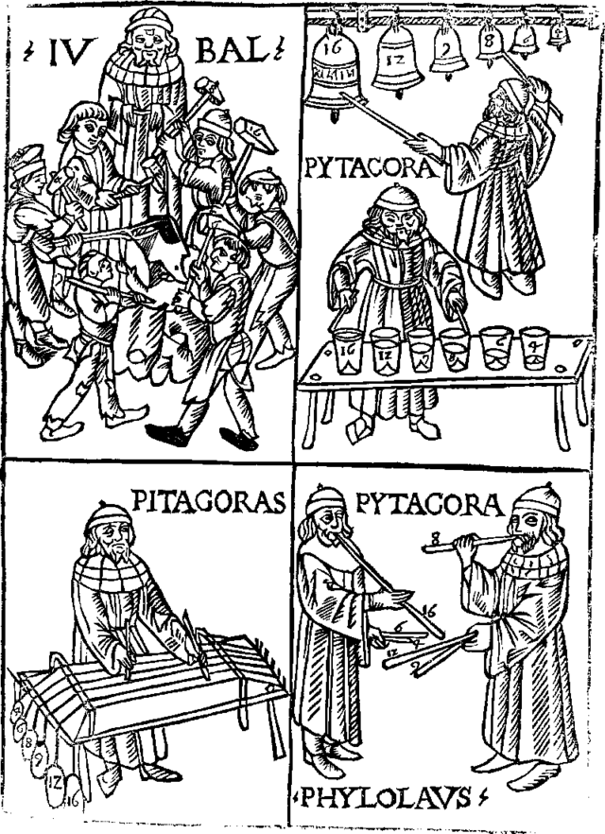

The following diagram, known as the tetraktys, became one of the central symbols of the Pythagoreans, representing the pattern of divine harmony.

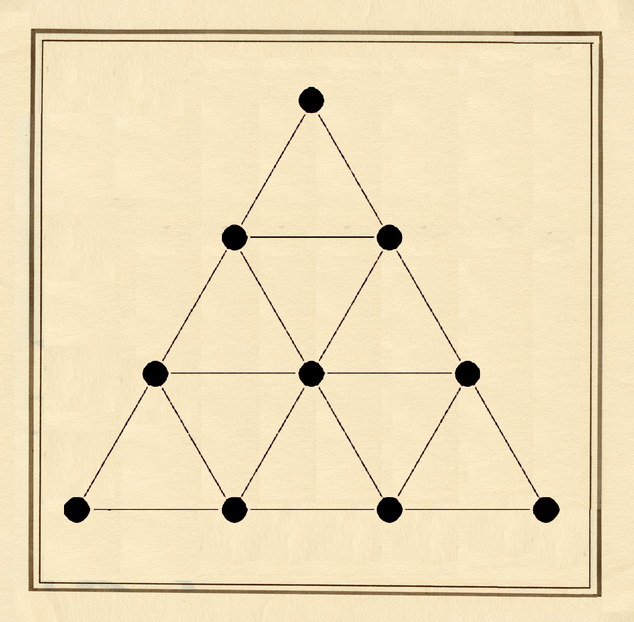

The ordering of the dots in the triangle suggests a proportional relationship: 2:1, 3:2, 4:3. In music these proportions define what are known as the “perfect” intervals. The ratio of 2:1 became known as the octave; 3:2 is a perfect fifth, 4:3 a perfect fourth. For centuries, both were built on the foundation of Pythagoras’s discovery of perfect proportion.

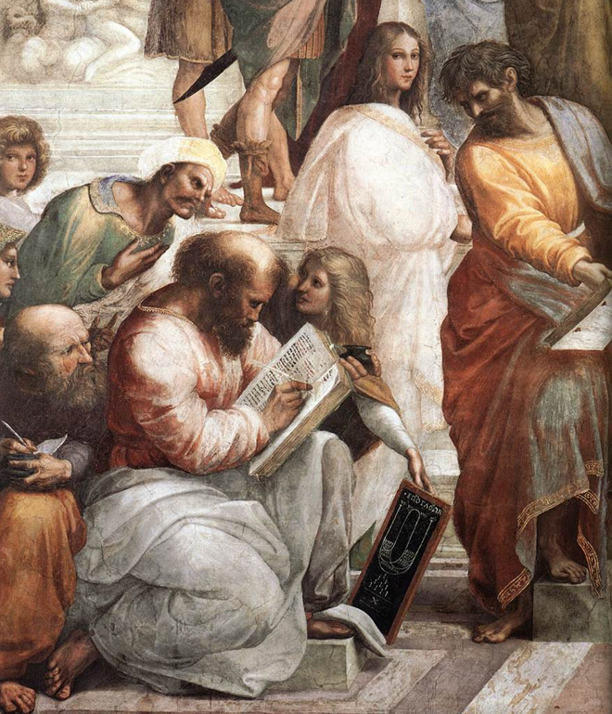

Raphael’s School of Athens. Pythagoras is writing in a book with centuries of philosophers peering to copy his wisdom; a woman, likely his wife Theano, holds the chalkboard with the tetraktys.
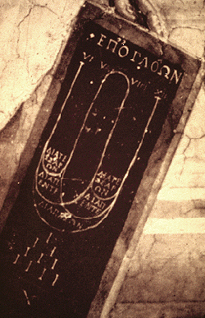
Detail of Raphael’s School of Athens, showing the geometric relationships and the tetraktys

Instruments were tuned based on the perfect intervals of the octave and the fifth. These notes were seen as “consonant” with characteristics that were deemed pleasing and edifying for the soul. Other intervals (such as the third or sixth) were not mathematically pure and were perceived as “dissonant”. Thus a melody would be comprised of notes that were both “consonant” and “dissonant”, both pure and impure.

For most of history, Western music was monophonic, meaning only a single vocal line was present , sometimes accompanied by rhythm instruments such as drums or cymbals. As music evolved to encompass the sounding of two or more notes simultaneously, harmony resulted. Simultaneous soundings of the perfect octave, perfect fifth and perfect fourth were encouraged. Other intervals were viewed as chaotic, unpleasant and even dangerous for one’s spiritual well being. For centuries, the interval of a tritone (Diminished 5th/augmented 4th) was thought to be so distasteful that it might lead the soul to perdition and moral peril and was nicknamed the “devil’s interval”. The Pythagorean tuning system dominated Western music until the end of the Renaissance when the Well Tempered or Mean Tuning systems emerged. This compromised all of the “perfect” intervals, with the ironic result that Western music has been “imperfect” and “out of town” ever since.

Pythagoras’s ideas of Divine Proportion and the Pythagorean curriculum for cultivating a state of spiritual harmony found their way into the writings of many early Christians, including Pseudo-Dionysus and Boethius. Perhaps most importantly for the history of education, they became the basis of the Seven Liberal Arts. The studies of Grammar, Rhetoric and Dialectic were added as a prelude to the Quadrivium in the great School of Chartres as scholars sought to perceive the divine Logos in each subject. Carved above the North Porch is the figure of Pythagoras himself. In many ways, the entire school of Chartres was a revival of the Pythagorean Brotherhood. Before one could commence the study of theology, one first needed to awaken to perceive the Divine Pattern in words, numbers, music and the stars. Only then would one be ready to discuss God as God.

Inside of the great cathedral, the proportions of mirror the divine harmony of the tetraktys, with archways and windows set in brilliant illumination of the “perfect” mathematical rations. Architecture has been described as frozen music, and nowhere may that be more evident than in the musical harmonic ratios of Chartres.

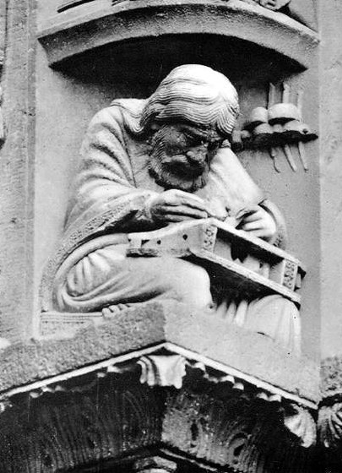
Carving of Pythagoras at Chartres Catehdral, representing the power of music

The concordance between number, music and geometry is also palpably obvious in the image of The Temple of Music by Robert Fludd, a 17th century English philosopher and cosmologist who corresponded with Johannes Kepler.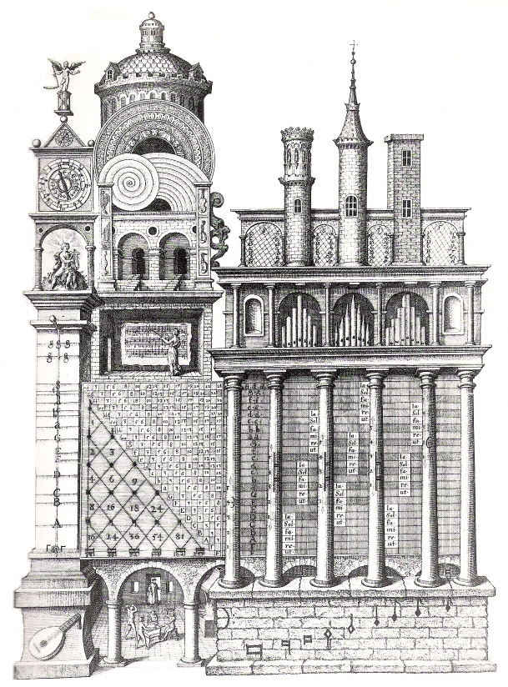 Temple of Music, Robert Fludd
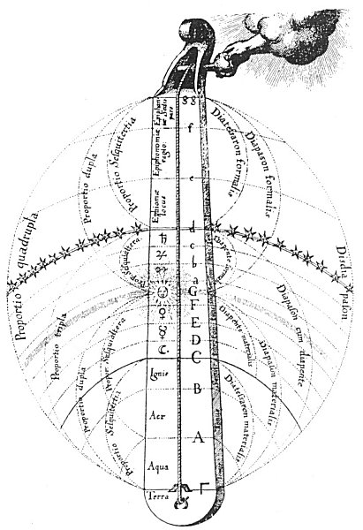
Lyre of God, Robert Fludd

We see evidence of the Pythagorean search for order and symmetry in the universe in Robert Fludd’s Lyre of God. Here, each musical note is associated with an element (Earth, Water, Air, Fire) or planet. The proportions between them create the geometric rations akin to the musical sounds of the perfect intervals. God’s hand is literally “tuning” the universe through the correpsondances between nature and music

In the Pythagorean view, each planet gives off a sound, and all the planets together create a divine symphony. The universe itself is filled with invisible music. This Musica Celestis, or Harmony of the Spheres, is an idea that has captured the imagination of artists, poets, philosophers and scientists ever since. It was an obsession that drove Johannes Kepler’s to create a new model of the solar system. We see it in illumination created by the great 12th century Benedictine Abbess Hildeagard von Bingen.

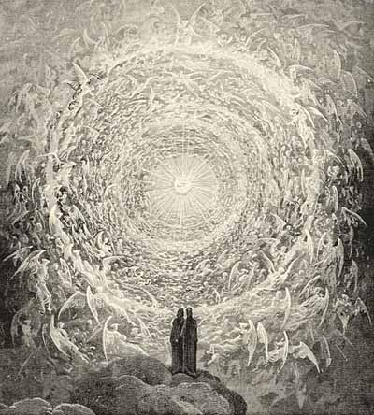

Dante Aligheiri referenced the wisdom of Pythagoras eight times in his writinga, and his culminating vision in the Divine Comedy is Paradiso’s Rose, where each petal is filled with divine song. Across the centuries, the Pythagorean ideal of tuning the soul to be in harmony with the divine has echoed forth.

What A Pythagorean Perspective Can Offer Our World Today

The Western world has become marked by increasing specialization and isolation, with subcategories of divisions within academic fields. A Pythagorean approach seeks to find the unifying principle beneath and behind all things. Firmly rooted in the stance that there is an organizing pattern that is both intelligible and beautiful, the Pythagorean approach to life is suffused with reverence for all creation.

We do not need to choose between science or spirituality, art or math, ethics or politics. Each one is an essential and radiant expression of the One. Mathematics is not a merely rational dissection and explanation of dry formulas, but a cosmological perspective that affords an every expanding landscape of wonder.

A Pythagorean perspective sees nature as an expression of the divine, and shrinks from any exploitation of animals or land. A Pythagorean approach suggests that the greatest wisdom flourishes when we can honor the seeming contradictions within our human existence. From silence and humility, within community and friendship with all beings, we can find a meaning far deeper than our individual pursuits.

Throughout the centuries, the ideals of the Pythagoreans have bubbled up as if from some neglected and forgotten fount, and when they did so, the world was re-enchanted. In the first few centuries in Alexandria, Egypt and in the School of Chartres during the 12th century, a holistic Neo-Pythagorean approach led to astonishing advancements in both science and architecture. Now in our own time, His Highness The Prince of Wales has issued another clarion call for integration and harmony. We do not need to begin in a vacuum: the Pythagoreans provide a pattern for renewal and inspiration to reclaim a life saturated with beauty where science and the sacred are both in the service of humanity. In following in their reverent footsteps, may we, too, come to find ourselves part of the divine chorus.

Pythagoras Said…
By Kayleen Asbo

…There is a symphony that never ceases
Stretching out its ecstatic shimmer
Through the waves of the sky
Across the ripples of the late summer’s shore
And into the depths of your own being.
If you are still,
You can ride the crest of its vibrations.
If you quiet your mind,
You will know the voices of the stars.
Tune, tune, tune your heart
To hear the eternal celestial song.

Kayleen Asbo, Ph.D is an adjunct professor of mythology at the Pacifica Graduate Institute in Santa Barbara and a lecturer for the Osher Lifelong Learning Institutes of UC Berkeley, Dominican University and Sonoma State University in California. She holds advanced degrees in three subjects: Mythological Studies, Psychology and Piano Performance. The Music Historian in Residence for the Santa Rosa Symphony, Dr. Asbo is also a preconcert lecturer for the San Francisco Opera and the Mendocino Music Festival and offers courses, workshops and yearly pilgrimages to Europe on the intersection of the arts, psychology, cultural history and spirituality. Read more at www.kayleenasbo.com

For Further Reading

Pythagoras Stanford Online Encyclopedia of Philosophy

Measuring Heaven: Pythagoras and His Influence on Thought and Art in Antiquity and the Middle Ages, Christine L. Joost-Gaugier, Ithaca: Cornell University Press, 2006.

Pythagoras and the Pythagoreans: A Brief History, Charles H. Kahn. Indianapolis: Hackett Publishing, 2001.

To Think Like God: Pythagoras and Parmenides, Arnold Hermann. Las Vegas: Parmenides Publishing, 2004.

The Elements of Music: Melody, Rhythm and Harmony. Jason Martineau. New York: Walker Publishing Company, 2008.

