#### 

THRESHOLDS

Mythica has crossed another threshold: our first pilgrimage. *In the Footsteps of Mary Magdalene* led thirteen lucky pilgrims through Provence, France, peaking our journey at the sacred caves of La Baume. We will offer an encore of the Magdalene pilgrimage next June. Our waitlist awaits you!

Our mythologist, Kayleen Asbo, returns to France in August to gather material for her book on spiritual journeys. Check her website as she and her daughter, Anissa, blog about trekking the Andy Goldsworthy trail to Taize, with excursions to Medieval monasteries and modern Buddhist retreat centers.

This fall, Mythica offers ongoing classes and one-day workshops covering the from the wisdom of Carl Jung and Hildegard of Bingen, to the riveting hidden history of classical music masterpieces. History, art, music, poetry, and opportunities for inner reflection are woven with Kayleen’s orchestration of impeccable scholarship and passionate performance.

Please join us this fall for intellectual journeys to invigorate your mind and stir your spirit. Check Kayleen’s website for details, as well as news reports and videologs from sacred sites in Europe featuring Anissa, the newest member of our Mythica team!

www.kayleenasbo.com

From “For the Traveler”

By John O’Donahue

…When you travel

A new silence

Goes with you,

And if you listen,

You will hear

What your heart would

Love to say.

A journey can become a sacred thing:

Make sure, before you go,

To take the time

To bless your going forth,

To free your heart of ballast

So that the compass of your soul

Might direct you toward

The territories of spirit

Where you will discover

More of your hidden life,

And the urgencies

That deserve to claim you.

May you travel in an awakened way

Gathered wisely into your inner ground

That you may not waste the invitations

Which wait along the way

to transform you.

-From *To Bless the Space Between Us*

Summer 2014, Issue 2

Mythica notes

Chantilly Codex, 14th century

# Hold Your HEAD IN YOUR HEART

**The Road Less Travelled:**

**Jung and the Path of Individuation**

**September 20**

**(see next page)**

**Francis and the Path of Joy**

**Saturday, October 19**

**10:30-4:30**

**Teresa and the Path of Ecstasy**

**Saturday, November 15**

**10:30-4:30**

Paths of Wisdom Workshops

**Paths of Wisdom**

Monthly Workshops at St. John’s, Ross

#### Mythica will sponsor monthly workshops with Kayleen Asbo that bring to light the perennial wisdom of great thinkers, poets, artists and saints in day-long programs that weave lecture, art slideshow, guided journaling, small group discussions and private labyrinth walks with live music.

#### $150.00 workshop fee includes a catered lunch

#### For more information: www.kayleenasbo.com

# **The Road Less**

# **Traveled**

**C.G. Jung and Midlife Spiritual Development**

**Saturday, September 20**

10:30 am-5:30 pm, plus evening labyrinth walk

St. John’s Episcopal in Marin

14 Lagunitas Road, Ross

$150 includes catered lunch

register at www.kayleenasbo.com

In the middle of our life, we often find ourselves in a place of dryness, a Dante-like dark wood where we have lost our way. What once nurtured us has lost its savor; the elements of life that we once found so enticing and fulfilling now seem empty and devoid of meaning. This is exactly the point, Carl Jung discovered, at which the life of the soul is ready to emerge. The second half of a full life, Jung found, is about opening to Mystery, reclaiming the Authentic Self and finding the place where we have the enthusiasm of a young child.

No figure embodies this midlife flourishing better than Hildegard of Bingen. She was given to a monastery at the age of 8 and spent her youth in silence and seclusion. At the age of 42, her spiritual life exploded. In the second half of her life she became a composer, author, medical healer, botanist, artist, abbess, a counselor to kings and a stern prophet to popes.

In this one-day workshop using the tools of Jungian Psychology and stories of Hildegard, we'll explore practices that uncover our own depths and hidden vitality. Though music, art, poetry and somatic exercises, we’ll seek the path to our own greatest fulfillment, the place where, in Hildegard’s words, we are “green and juicy with the sap of life”.

Register at www.kayleenasbo or call (707) 304-0767

The Road Less Travelled:

*C. G. Jung, Hildegard of Bingen*

*and the Path of Individuation*

**Saturday, September 20 from 10:30 am-5:30 pm**

plus an optional evening labyrinth walk

$150.00- Scholarships available

**St. John’s Episcopal Church in Ross**

**14 Lagunitas Road**

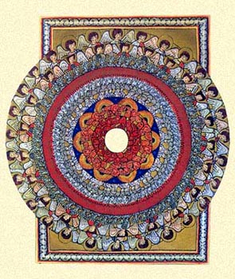

Fall 2014: Ancient Greece through the Renaissance

October 3: Free Introductory Class

October 17: Divine Harmony: Pythagoras and the Music of the Spheres

October 24: Cathedral and Cloister: Music of Hildegard and Notre Dame

October 31: Death and the Maiden: Song of the Sibyl

November 7: Drunken Monks, Mirth and Madness: *Carmina Burana*

November 14: Music for the Black Madonna: *Cantigas de Santa Maria* and the *Llibre Vermell*

November 21: Love, Longing and the Troubadours of France

Symphonies of the Soul:

Music History Through the Ages

Friday at St. John’s in Ross, 10:00-11:30 am

$150.00 per term or $30.00 per drop-in class

T

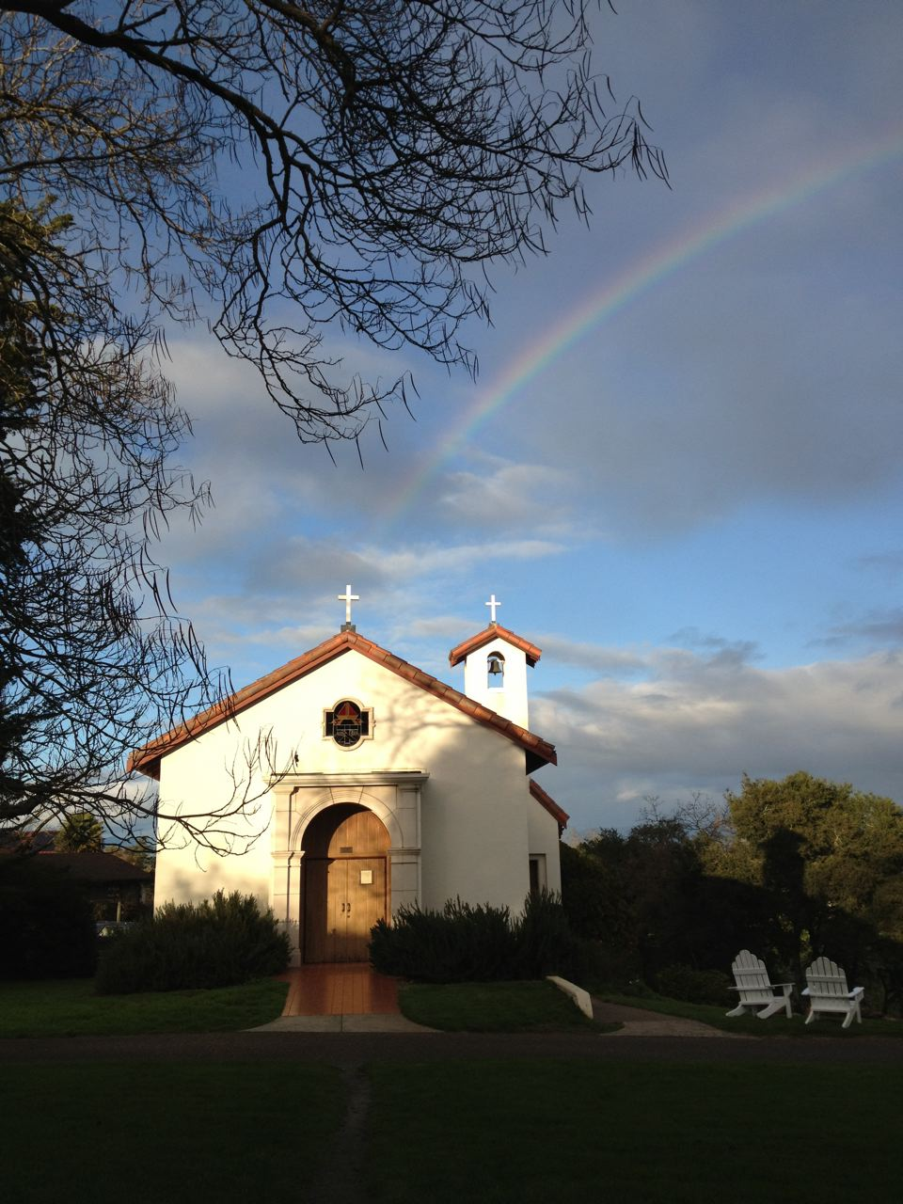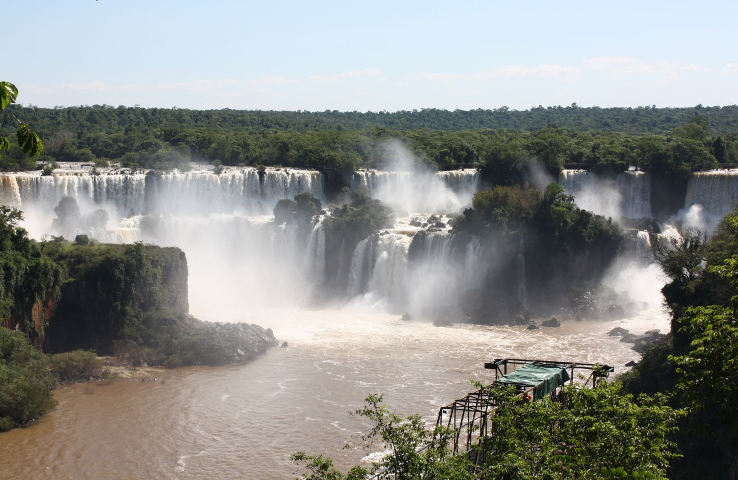

Wisdom of the Heart: An Advent Retreat

December 19-21, 2014

Join Kayleen at beautiful Bishop’s Ranch in Healdsburg for a three-day contemplative retreat of chant, poetry, and an introduction to practices of Benedictine spirituality, with sustained periods of silence.

$245.oo includes meals and lodging

Limited enrollment. Please register by calling Shannon at (707) 433-2440

Or register online at:

https://thebishopsranch.wufoo.com/forms/r12bxc3q00e80nu/

**West Wind #2**

***by Mary Oliver***

You are young.  So you know everything.  You leap  
into the boat and begin rowing.  But listen to me.  
Without fanfare, without embarrassment, without  
any doubt, I talk directly to your soul.  Listen to me.  
Lift the oars from the water, let your arms rest, and  
your heart, and heart’s little intelligence, and listen to  
me.  There is life without love.  It is not worth a bent  
penny, or a scuffed shoe.  It is not worth the body of a  
dead dog nine days unburied.  When you hear, a mile  
away and still out of sight, the churn of the water  
as it begins to swirl and roil, fretting around the  
sharp rocks – when you hear that unmistakable  
pounding – when you feel the mist on your mouth  
and sense ahead the embattlement, the long falls  
plunging and steaming – then row, row for your life  
toward it.